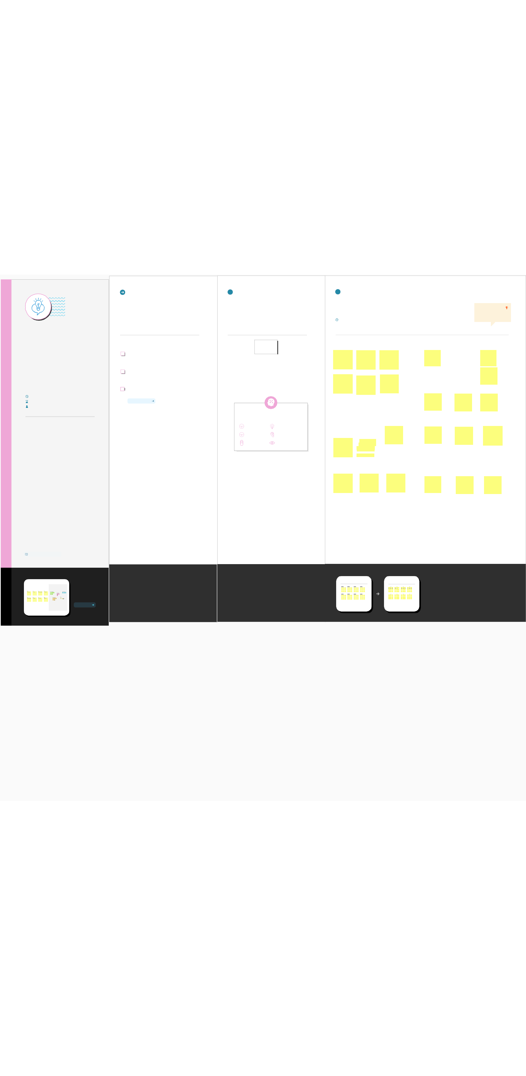

Template

Brainstorm

& idea prioritization

Use this template in your own brainstorming sessions so your team can unleash their imagination and start shaping concepts even if you're not sitting in the same room.

10 minutes to prepare

1 hour to collaborate

2-8 people recommended

Before you collaborate

A little bit of preparation goes a long way

with this session. Here’s what you need

to do to get going.

10 minutes

- Team gathering
Define who should participate in the session and send an invite. Share relevant information or pre-work ahead.

- Set the goal

Think about the problem you'll be focusing on solving in the brainstorming session.

- Learn how to use the facilitation tools
Use the Facilitation Superpowers to run a happy and productive session.

Open article

1

Define your problem statement

What problem are you trying to solve? Frame your problem as a How Might We statement. This will be the focus of your brainstorm.

5 minutes

PROBLEM

How m ight we [your

problem statem ent]?

N ow adays road signs and

speed limits are static, road

signs and speed lim its can’t

be changed in som e cases.

If we replace static signs

with dynam ic signs, the

signs can be changed at any

tim e and anywhere, even

we can change the signs

during a sudden change in

weather conditions or if any

accidents happened we can

change the signs & tell the

people to have another

route or direction. If we

replace ordinary signs with

sm art signs a large num ber

of happening accidents can

be reduced and we can

save a lot of tim e by

reducing the traffic. Even

this type of system is helpful

for education and m edical

institutions.

Key rules of brainstorming

To run an smooth and productive session

Stay in topic. Encourage wild ideas.

Defer judgment. Listen to others.

Go for volume. If possible, be visual.

2

Brainstorm

Write down any ideas that come to mind

that address your problem statement.

10 minutes

Indicating | showing safety | indicating
instructions if | showing safety
instructions if | measures
schools or | during travelling. | about road
hospitals near | for example: | conditions
to the road | seat belts etc...
educating | showing | showing | details
about | showing | about | weather
about | instructions and | about
various | educating about | conditions |  | like
various | educating about | temperature |  | and
various | Lane Discipline |  |  | and
traffic signs | Lane Discipline | humidity values
 |  | Limiting the
 |  | speed of
 |  | vehicle in hill
Showing smart | water level | region when
Showing smart | water level | fog is high
signs during | water level
signs during | indication in
taking turns in | indication in
taking turns in | underground
hilly regions or | underground
hilly regions or | roads during
in highway | rainy season
roads | rainy season
Introducing a | Indicating the | signalling to

Indicating

traffic details

to save

peoples time

Animals | showing
Animals | details in
crossing | terms of
detections | emergency
 | situations
Indication of
vehicle entry | overtake
from normal | overtake
from normal | indication
road to | indication
highway

TIP

You can select a sticky note and hit the pencil [switch to sketch] icon to start drawing!

Indicating
speed limits

in different

road

structures

indication of

four way

junction

indication of

railway

roads

sign indication if vehicles are taller than railway bridges

Share template feedback

Need some

inspiration?

See a finished version

of this template to

kickstart your work.

Open example

beep or sound | roaming wild | avoid accidents
system in signs | roaming wild | in connection of
system in signs | animals in | in connection of
for blind | animals in | service road
for blind | forest roads | service road
people | forest roads | and bypass road

sign | speed braker | showing
indications | indications | speed details
in digital | for vehicle | to avoid
mode | users | accidents



